Science Centre Singapore Opens RoboFest 2026 with Six Robots in Public Pilot
Four-day robotics and AI festival opens with six robots deployed in visitor-facing roles in the lead up to the New Science Centre

Singapore, 9 APRIL 2026 - Science Centre Singapore opened RoboFest 2026: Meet Tomorrow, Today, a new four-day public festival on robotics and Artificial Intelligence (AI) with six robots deployed in a live public pilot across the Centre’s galleries. Running until 12 April, the RoboFest was officiated by Ms Jasmin Lau, Minister of State, Ministry of Education and Ministry of Digital Development and Information. The six robots are part of the Centre’s first structured public pilot of gallery robots.

Comprising wheeled and humanoid models, they are being deployed in visitor-facing roles such as guides, ushers and performers alongside the Centre’s Science Educators. The pilot gives visitors a chance to see how robotics can support learning and engagement in a public setting, while allowing the Centre to test how such technologies may enhance future visitor experiences.
This launch comes as AI and robotics become a bigger part of everyday life, but often still feel abstract or out of reach for many families. RoboFest is designed to make these technologies more visible, approachable and relevant by bringing them into a public environment where visitors can see them in action, interact with them directly and explore how they are already being applied in the real world.
“There is often a gap between where technology is heading and where many people feel comfortable. Parents may worry about being left behind, while children are naturally curious but do not always have the chance to explore these technologies in a meaningful way. RoboFest is designed to help close that gap by bringing robots and AI out of specialist spaces and into a public environment where families can discover, question and learn together,” said Ms Tham Mun See, Chief Executive, Science Centre Board.
She added, “The six robots we are piloting are not here as a novelty. We want to understand how they can support visitor engagement, navigation and programming alongside our educators, and what role they might play in future learning environments. That makes RoboFest not just a festival, but a useful live testbed for us.”
Six Robots in Action Across the Festival
The six-robot pilot marks the Centre’s first structured trial of social robots in gallery and event settings. Throughout RoboFest, these robots will take on active roles as performers, facilitators, and guides. Humanoid robot G1 co-emceed the launch proceedings and appeared as a live streamer. Festival attendees will also encounter robots supporting wayfinding, audience engagement and programme moments such as the comedy skit My Colleague is a Robot Dog and the Robot Dog Fire-fighting showcase.
The pilot will continue until Nov 2026, allowing the Centre to study how guests respond to robots in educational and public-facing settings, and to assess how such technologies could be integrated into future exhibitions and programmes.
Community Participation beyond the Festival Floor
As part of RoboFest, the Centre is inviting the public to help name its new robotic squad via a Social Robots Naming Contest running until 12 April on Science Centre Singapore’s Instagram platform. The initiative is designed to make robotics feel more relatable and give the community a role in shaping how these robots are introduced to the public.
The Centre is also piloting 'Dog Meet Dog', a pet-friendly outdoor event on 11 and 12 April at the Kinetic Garden, where families can bring their dogs to meet G2Pro, the resident robot dog. The programme will include obstacle courses, complimentary pup cups and treats while also giving the Centre to gather insights on pet-friendly operations in designated outdoor spaces.
Making Robotics and AI Accessible to the Public
Spanning four experiential zones, RoboFest presents robotics and AI in formats designed to guide guests from curiosity to deeper understanding.
- The Playground features high-energy demonstrations including a Robot Boxing showdown, a Robot Dog Fire-fighting challenge, and the comedy performance My Colleague is a Robot Dog.

- Robotics in Real Life zone showcases applied robotics projects addressing real-world challenges, from assistive technologies to robotics research developed by universities and partners.

- The Learning Hub focuses on guided experiences such as drone coding, humanoid robot programming, and AI prompt-crafting activities designed to build foundational understanding of emerging technologies.

- The RoboCup Arena brings together human teamwork and machine capability with the 18th edition of RoboCup Singapore, which also serves as the national selection platform for teams representing Singapore at regional and international RoboCup competitions.
Strengthening Robotics and AI Learning Ecosystems
RoboFest also brings together partners from across Singapore’s research, education and technology ecosystem. Alongside Science Centre Board, Institutes of Higher Learning and industry collaborators are presenting demonstrations, applied robotics projects and learning experiences showcasing how robotics and AI are being developed and applied in real-world contexts.
Complementing these showcases, RoboFest will also feature a series of talks and sharing sessions by industry experts and educators, offering deeper insights on emerging trends in robotics and AI, as well as the evolving role of these technologies across different sectors and our day-to-day lives. Please refer to the Annex for details on the speaker sessions.
The Centre is also working closely with schools to nurture interest in AI and robotics among students. Three schools - Beatty Secondary School, Clementi Town Secondary School and Kuo Chuan Presbyterian Secondary School - are showcasing student projects at RoboFest, highlighting how they encourage students to explore these emerging technologies. The Centre has also piloted its Humanoid-AI workshop with Fuhua Primary School, Yew Tee Primary School and Zhenghua Secondary School, and will be collaborating with Boon Lay Garden Primary School and Jurong West Secondary School to further strengthen its robotics education programmes.
RoboFest is supported by a diverse ecosystem of partners advancing robotics education and engagement, including the Ministry of Education, public agencies such as National Robotics Programme, SGInnovate and AI Singapore, as well as institutes of higher learning including the National University of Singapore (NUS) and Nanyang Polytechnic (NYP).
Industry collaborators such as Google Cloud x Google for Education, Duck Learning (partner of LEGO® Education) and applied robotics partners including Weston Robot, Stellaris Robotics and Stick ’Em are also contributing workshops, demonstrations and learning experiences throughout the festival.
RoboFest 2026 reflects Science Centre’s broader effort to make emerging technologies easier for the public to understand and engage with, not only through exhibitions, but through shared experiences that connect education, culture and everyday life. Insights from the six-robot public pilot will also help inform how the Centre thinks about future programming and visitor experience design, including for the New Science Centre.

Ticketing Information
Tickets for RoboFest 2026 are available here.
Singaporeans and Permanent Residents
Weekdays (Thu, 9 April & Fri, 10 April): Adults $6 | Children and seniors $4
Weekend (Sat, 11 April & Sun, 12 April): Adults $10 | Children and seniors $6
Standard Admission
Adults $16 | Children $10
Find out more about RoboFest 2026 here.

For enquiries, please contact:

Zeno Group Singapore
Batrisyia Johari
batrisyia.johari@zenogroup.com
+65 9384 5564

Science Centre Singapore
Jyotika Thukral
jyotika_THUKRAL@science.edu.sg
6425 2541

About Science Centre Singapore

Science Centre Singapore, an informal educational institution and leading regional Science Centre, along with its group of attractions, brings out the wonders of science, technology, engineering and mathematics (STEM) through its unique blend of exhibitions, educational programmes and events. A custodian of creativity and innovation, Science Centre Singapore has captured the evolution of scientific developments for more than four decades. The Centre and its partners have played a pivotal role in transforming the way students and the public interact with and learn about STEM. Since 1977, the Centre has welcomed over 30 million visitors and inspired them with more than 1,000 exhibits spread across 14 galleries and outdoor spaces.

The Centre’s group of attractions include Omni-Theatre, Snow City and KidsSTOP^{TM️}. The Omni-Theatre, Southeast Asia’s first 8K 3D digital theatre with a 23m wide seamless dome screen, is an immersive destination like no other. Snow City is Singapore’s only permanent indoor snow centre offering an Arctic inspired experience at Singapore’s first ice gallery and snow chamber. KidsSTOP^{TM️} ️ - Where every child gets to Imagine, Experience, Discover and Dream - is Singapore’s first children’s science centre offering an enriching experience through purposeful play for children aged 18 months to 8 years old. For more information, please visit www.science.edu.sg.

ANNEX

TALKS AND SHARING SESSIONS

- Talk by Dr Efe Camci, A*STAR Institute for InfoComm Research on "From Airplanes to Flying Robots"
- Date: 9 April (Thurs) 2026, 3.00pm to 4.00pm
- Venue: Maxwell Auditorium

Session Synopsis | This talk takes the audience on an exciting journey from the fundamentals of flight to the cutting-edge world of aerial robotics. Starting with how airplanes generate lift and stay in the air, it gradually explores how drones learn to navigate, decide, and act autonomously. Drawing from real research, the session will showcase various drone capabilities from performing agile manoeuvres to physically interacting with their environment.
Speaker Profile  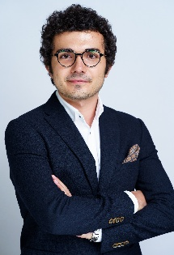 | Drone enthusiast who loves to explore how aerial robotics can enable novel real-world capabilities and make our lives a little better. Aerospace engineer by BS training, followed by a PhD in aerial robotics. Hands-on, outgoing, and outdoor guy at heart, with more than a decade of experience on guiding students.

- Talk by Dr Yau Wei Yun, A*STAR Institute for InfoComm Research on "Let’s Get Robot To Help Make Our Work Better"
- Date & Time: 10 April (Fri) 2026, 3.00pm to 4.00pm
- Venue: Mendel Auditorium

Session Synopsis | We have seen many videos of robots doing impressive performances. However, we also did not see many robots being used to help ease many of the dull, dirty and dangerous tasks required in the industrial and commercial settings. This talk will describe the technology required for robots to perform real-world tasks in our working environments and some of the prototype robots being tested in Singapore. The talk will also describe some of the recent developments in the area of robotics and AI that may impact our daily lives in the future.
Speaker Profile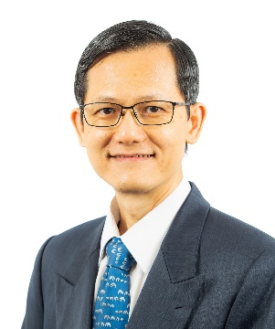 | Yau Wei Yun received his BEng (Electrical) from the National University of Singapore (1992), MEng degree (1995) and PhD degree (1999) from the Nanyang Technological University, Singapore. Currently he is with the A*STAR Institute for Infocomm Research as the Head for Robotics and Autonomous Systems division.  He and his team have developed several award-winning robotic solutions, including the MATAR, Xavier and Gibson robots and spun-off BotMind Pte Ltd to commercialize patrolling robots and Sensorbot Pte Ltd to commercialize the autonomous shelf reading robots.  He is the recipient of TEC Innovator Award 2002, Tan Kah Kee Young Inventors’ Award 2003 (Merit), Standards Council Distinguished Award 2007, MTI Firefly Silver Award 2020 for Most Innovative Project/Policy category and IES Prestigious Engineering Achievement Awards in 2006, 2023 and 2025. His research interests include embodied intelligence, robotic navigation and perception, multi-robot collaboration, novel robotic applications and biometrics and has published widely, with 18 patents granted and 200 publications.

- Sharing cum Dialogue Session by SGInnovate on “Robots, Real Impact, and You”.

- Date & Time: Thursday 9 April, 3.15 pm to 4 pm
- Venue: Mendel Auditorium

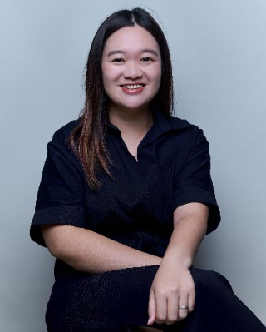 | Speaker: Samantha Tan, Assistant Director, Young Talent  People, SGInnovate  Synopsis: To introduce students to the world of deep tech and its real-world impact, including examples of robotics startups supported by SGInnovate, and to provide an overview of the Summation deep tech apprenticeship programme.

- Sharing by National Robotics Programme and SGInnovate on “The Future of Robotics and Embodied AI in Singapore’.

- Date & Time: Saturday, 11 April, 3.15 pm to 4 pm
- Venue: Mendel Auditorium

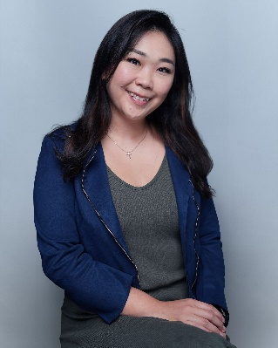   | Speaker:  Ms Priscilla Looi, Assistant Director, Learning & Engagement, SGInnovate  Ms Jennifer Woo, Senior Manager, National Robotics Programme  Synopsis: The session will introduce Singapore’s robotics and embodied AI ecosystem with talent pathways in the field.

- Talk by Dr Luke Soon, Partner and AI Leader, Digital Solutions, PricewaterhouseCoopers Risk Services Pte. Ltd on "AI is Your Superpower… But Don’t Let It Replace Your Brain”

- Date & Time: Sunday 12 April, 11 am to 12 pm
- Venue: Mendel Auditorium

 | Synopsis: The talk would cover what AI could do, the perils of over-reliance on AI, the role of struggling in learning, useful tips for children and parents.

